Handout no. 7

|  |  |
| --- | --- |
| **Name** | Faizan Azam, Muhammad Asad, Asad ur Rehman |
| **Reg.No** | 2019-EE-381, 383, 389 |
| **Marks/Grade** |  |

**EXPERIMENT # 7**

**Earth Overcurrent Relay**

**Objective:**

At the end of this lab session students will be able to

* Use De Lorenzo power system Protection kits.
* Implement Earth Overcurrent Relayby using De Lorenzo power system Protection kits.
* Relay behaviour in three phase systems for Overcurrent conditions.
* Determination of resetting ratio

**Introduction:**

A relay is usually an electromechanical device that is actuated by an electrical current. The current flowing in one circuit causes the opening or closing of another circuit. Relays are like remote control switches and are used in many applications because of their relative simplicity, long life, and proven high reliability. Relays are used in a wide variety of applications throughout industry, such as in telephone exchanges, digital computers and automation systems. Highly sophisticated relays are utilized to protect electric power systems against trouble and power blackouts as well as to regulate and control the generation and distribution of power. In the home, relays are used in refrigerators, washing machines and dishwashers, and heating and air-conditioning controls.

Although relays are generally associated with electrical circuitry, there are many other types, such as pneumatic and hydraulic. Input may be electrical and output directly mechanical.All relays contain a sensing unit, the electric coil, which is powered by AC or DC current. When the applied current or voltage exceeds a threshold value, the coil activates the armature, which operates either to close the open contacts or to open the closed contacts. When a power is supplied to the coil, it generates a magnetic force that actuates the switch mechanism

**Apparatus:**

* 1DL 1017R Resistive Load
* 1DL 2108T15Earth Fault Warning Relay
* 1 DL 1013T1 Three Phase power Supply Unit
* 1 DL 2108TAL-SW Three Phase power Supply Unit
* 1 DL 2108T17 LC load
* 1 DL Buz Acoustic continuity tester

**Overcurrent Relay:**

In an over current relay, there would be essentially a current coil. When normal current flows through this coil, the magnetic effect generated by the coil is not sufficient to move the moving element of the relay, as in this condition the restraining force is greater than deflecting force. But when the current through the coil increased, the magnetic effect increases, and after certain level of current, the deflecting force generated by the magnetic effect of the coil, crosses the restraining force, as a result, the moving element starts moving to change the contact position in the relay.Although there are different types of over current relays but basic working principle of over current relay is more or less same for all.

**Earth Fault Relay:**

Earth fault is the unintended fault between the live conductor and the earth. It also occurs, because of the insulation breakdown. When the fault occurs, the short-circuit currents flow through the system, and this current is returned through the earth or any electrical equipment. This fault current damaged the equipment of the power system and also interrupted the continuity of the supply.

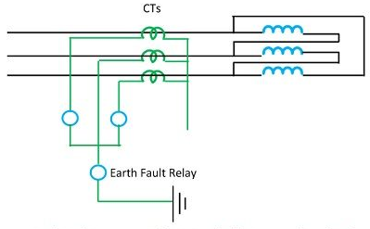

Figure 1: Earth fault Relay

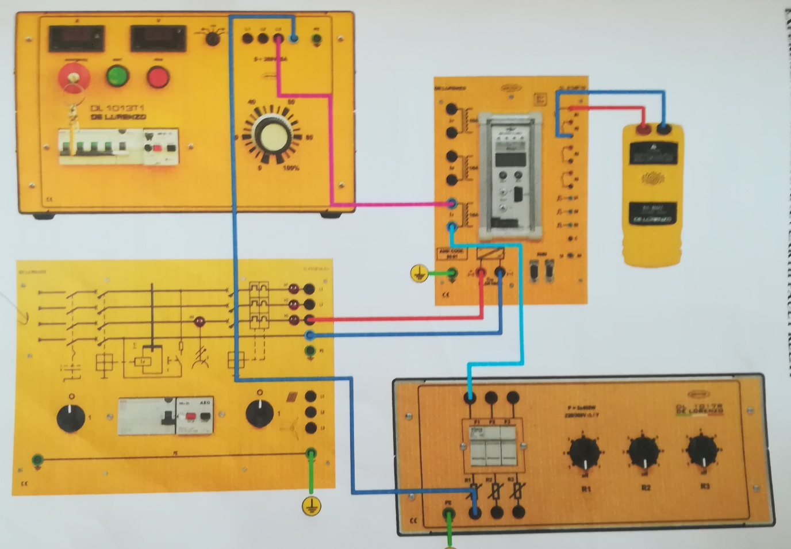

Figure 2: Experimental Setup of Earth Overcurrent Relay

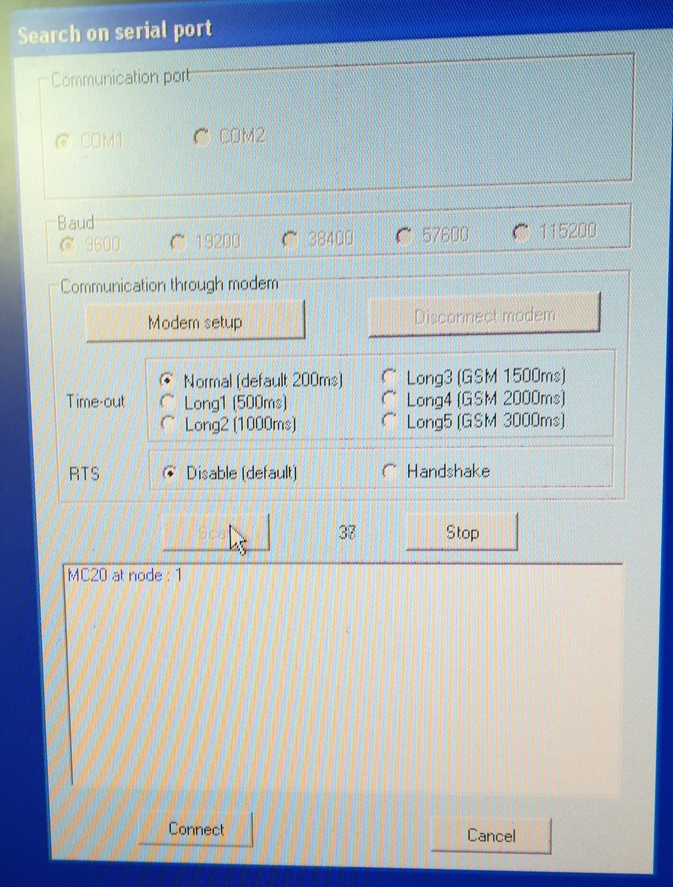

Figure 3: Create communication link of Relay

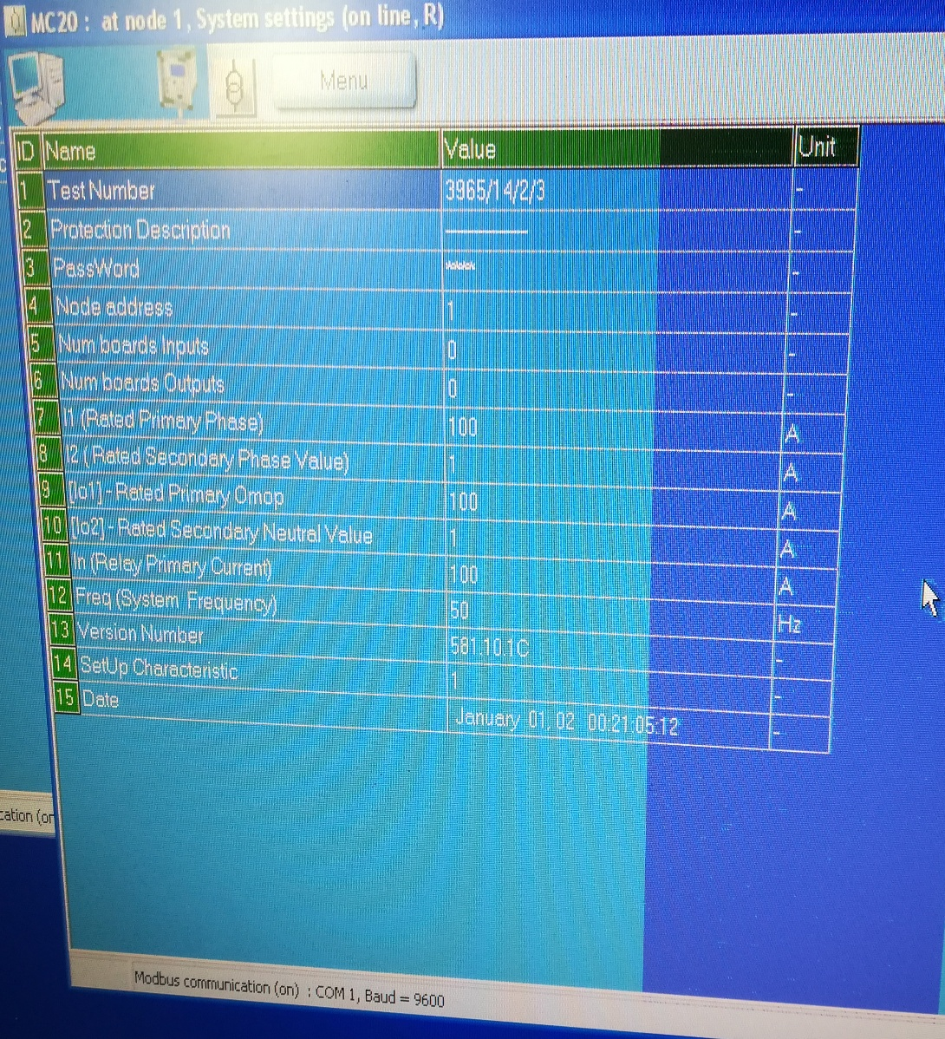

Figure 4: Setting of Fault current Value under fault condition

**Procedure:**

* Connect circuit as shown in Fig 2
* Create communication link of Relay
* Set the fault current value.
* Set three phase power supply voltage 380v and relay is not in operation
* Starting from 0V slowly increase the value of three phase supply voltage until the overcurrent relay operates.
* Then slowly decrease the voltage until the relay release and Reset the Relay.
* Apply same procedure for different timer conditions
* **For Set Value at 45:**

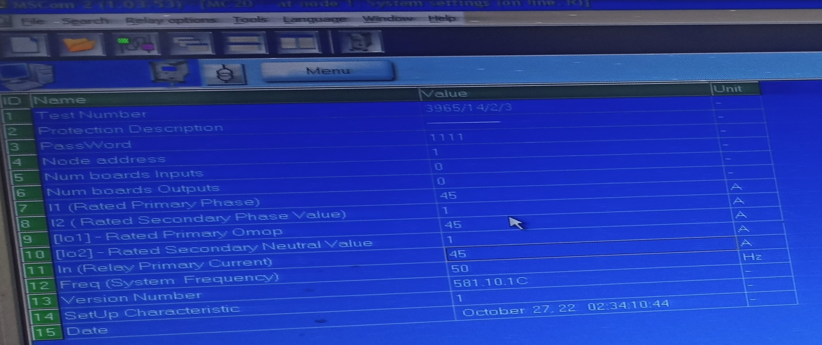

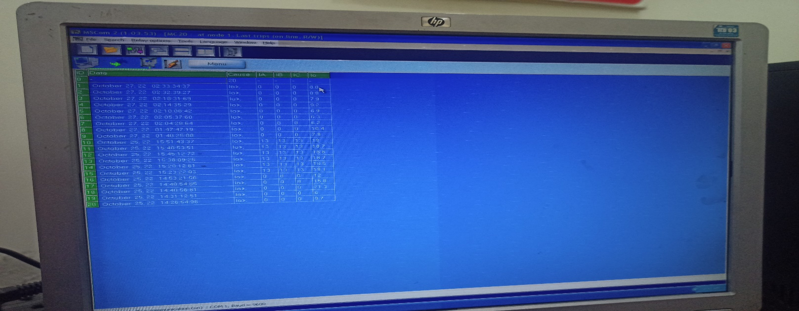

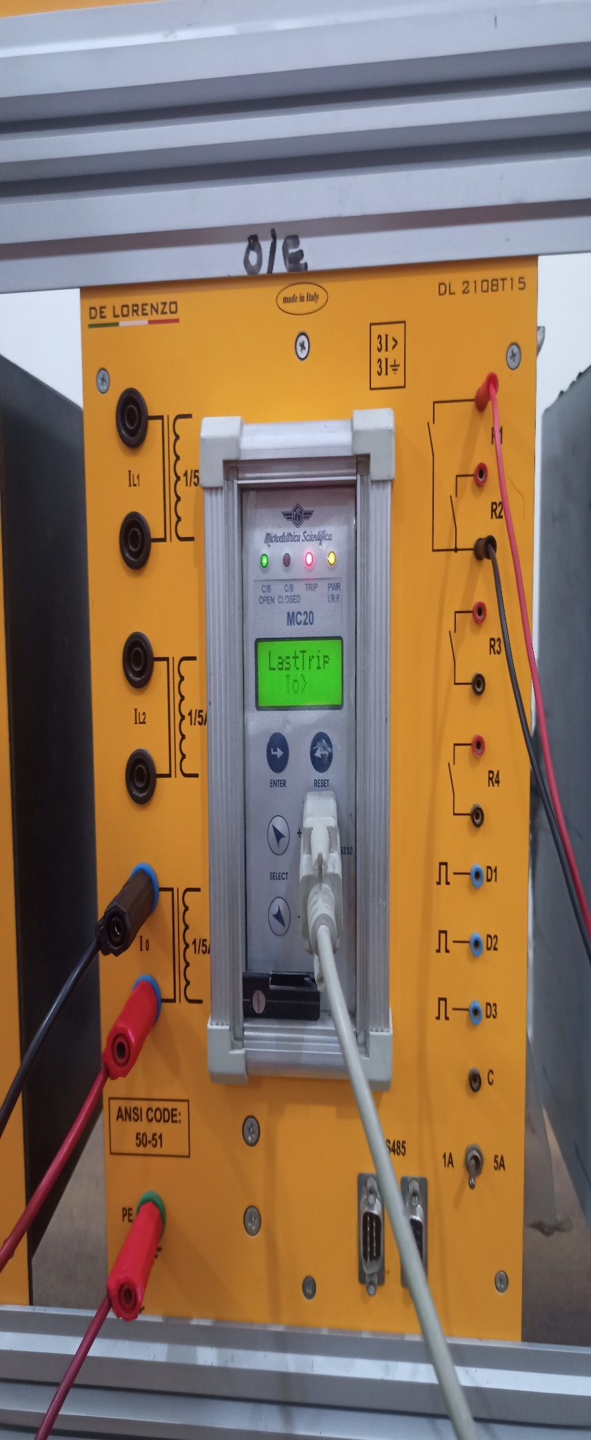

* **For Set Value at 50:**

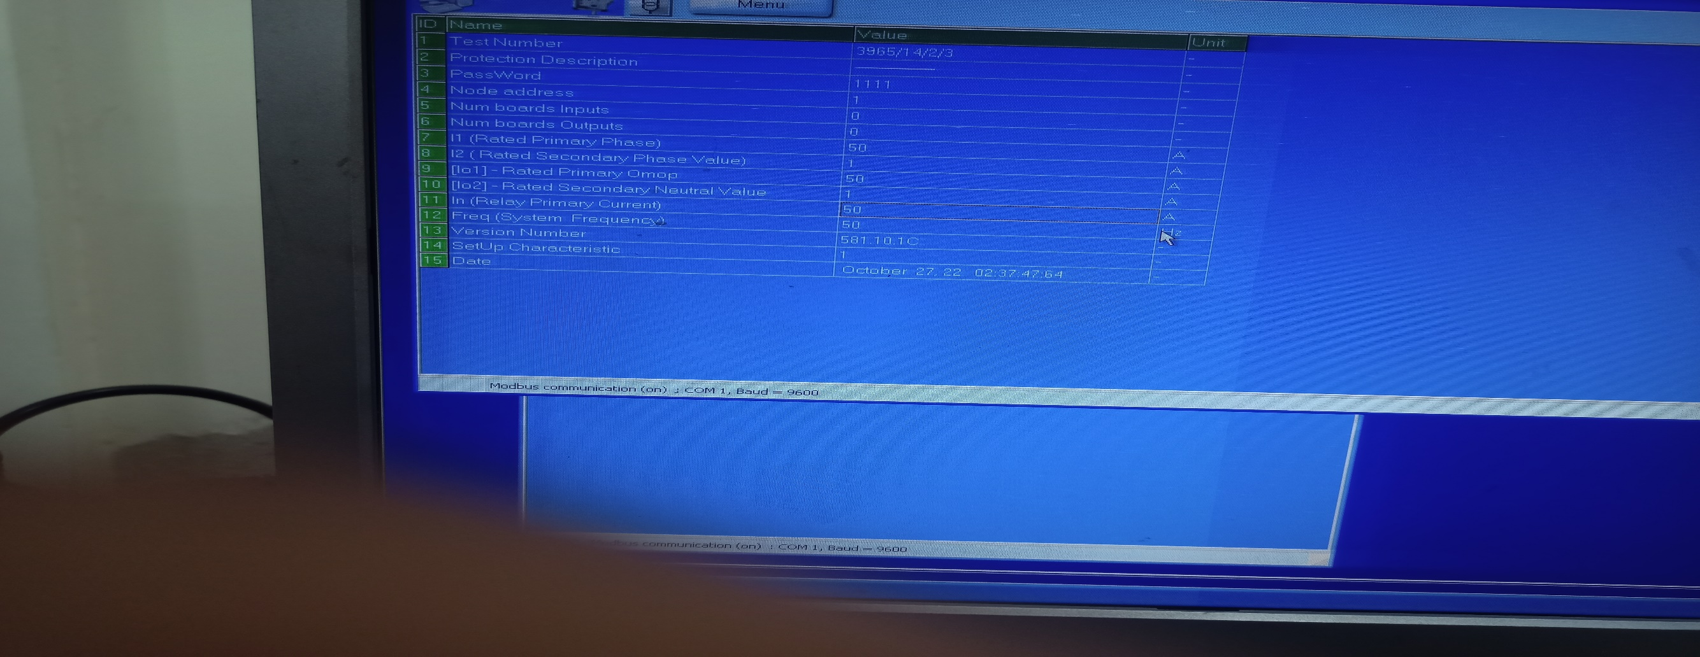

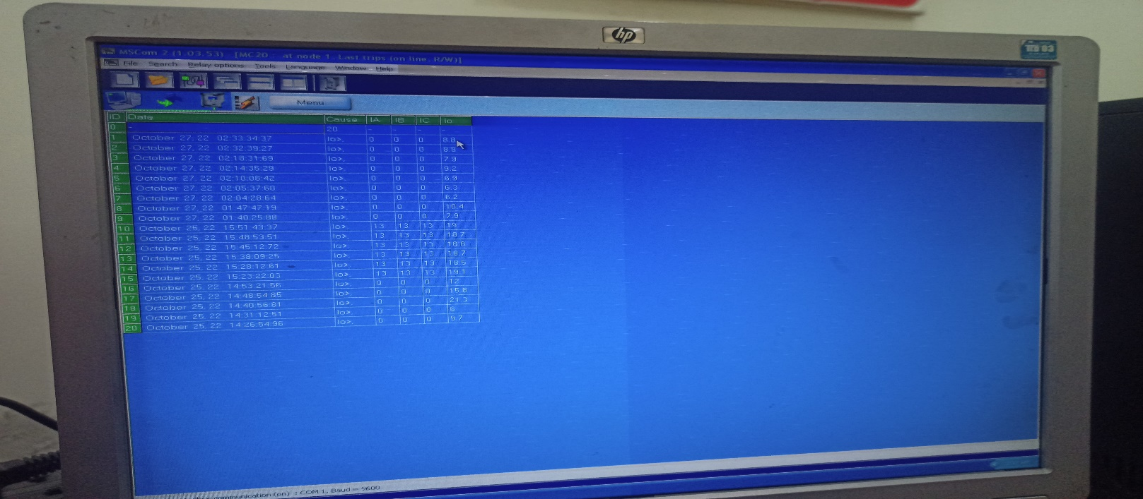

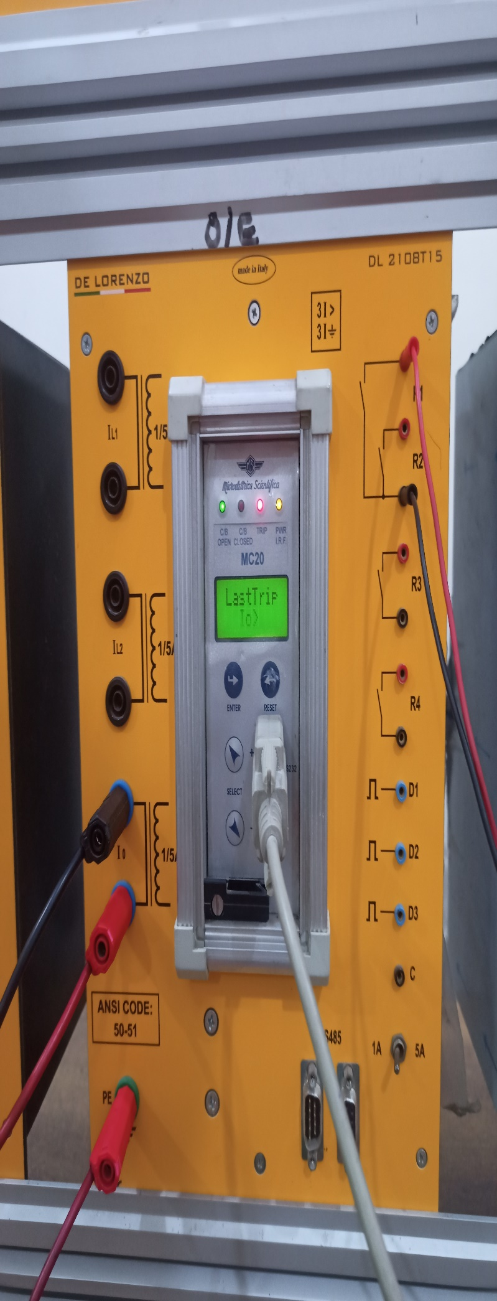

|  |  |  |  |
| --- | --- | --- | --- |
| **Set value of Io** | **Trip value of I01=** | **Measured Value** | **Error** |
| **45** | **9** | **8.8** | **2.2%** |
| **50** | **10** | **9.9** | **1%** |

* **Observation:**

In this lab, we learn about Earth overcurrent relay by using De Lorenzo power system protection kit. This is a basic protection relay. By using this relay, we can protect transformers and feeders from overcurrent and earth faults. It is a secondary relay which is connected to the current transformer of the object to be protected. In lab, we perform an experiment by using Earth overcurrent relay. First, we set value of current on primary side. Secondary current value is 1/5th of its primary value, which is actually fault current value. From above table, first set value is 45A. Then we calculate its trip value which is 1/5th of set value equal to 9A or measured value which is equal to 8.8A. On that value of current relay send the tripping signal to breaker. We use single line to ground connection and slowly increase current. When it reaches the fault current value, relay indicates tripping and send signal to breaker to open the circuit.

We conclude that:

➢ Earth overcurrent relay is computerized. So, chances of error is very small

➢ This relay has memory. So, it can store tripping values for future use.